

Designated Safeguarding Leads

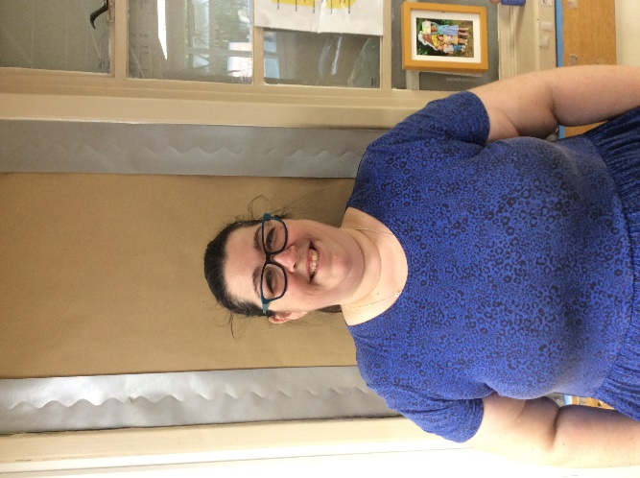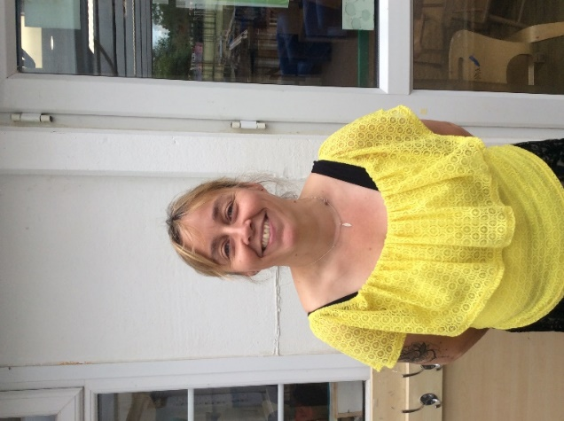

Richard Tyler

*Safeguarding Link Governor*

Permjinder Lidder

*Safeguarding Administrator*

Ruth Cotterill

*Class Teacher*

Diane Frainer

*Head Teacher*

Melissa Jeeves

*Class Teacher*